ATPManager Tutorial  
(under development)

PANORAMA

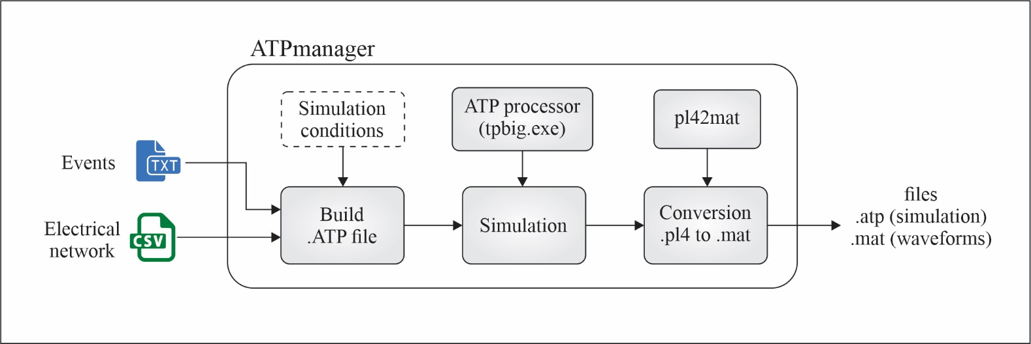

1. EVENTS CONFIGURATION

Electrical events to be simulated are organized as follows:

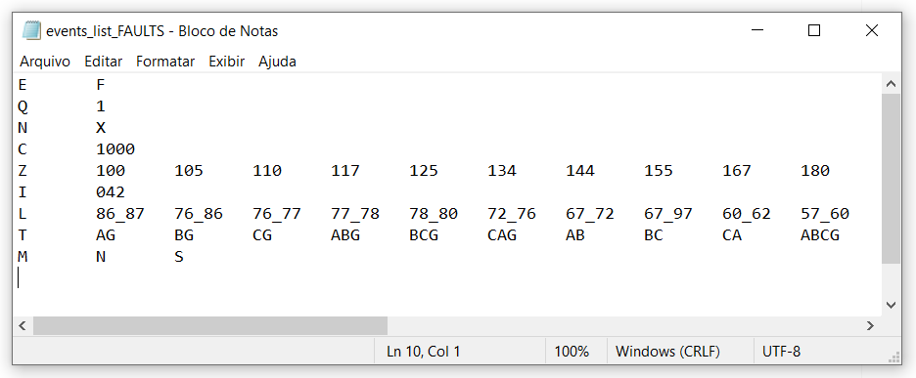

|  |  |
| --- | --- |
| **Abbreviation** | E |
| **Meaning** | Events |
| **Description** | System events, like fault and switching loads, capacitors and lines |
| **Values** | Events, can be:   * Faults (F) * Load Loss (LL) * Load Gain (LG) * Capacitor Loss (CL) * Capacitor Gain (CG) * System Loss (SL) – equivalent to line switching off * System Gain (SG) – equivalent to line switching on |

|  |  |
| --- | --- |
| **Abbreviation** | Q |
| **Meaning** | Quantity |
| **Description** | If the event is Load or Capacitor, Q indicates a power in kW or kVAr. For other events, this parameter is ignored. |
| **Values** | Any numerical value. Example: 40 means 40 kW |

|  |  |
| --- | --- |
| **Abbreviation** | N |
| **Meaning** | Node |
| **Description** | If the event is Load or Capacitor, N indicates the element’s local (node) |
| **Values** | Any node of IEEE test feeder (numerical values) |

|  |  |
| --- | --- |
| **Abbreviation** | C |
| **Meaning** | Condition |
| **Description** | System load condition, a percentage of the nominal condition described in electrical data (.csv files) |
| **Values** | Any numerical value normalized by 1000. Example: 425 means 0.425 or 42.5% of nominal power |

|  |  |
| --- | --- |
| **Abbreviation** | Z |
| **Meaning** | Fault impedance |
| **Description** | Fault impedance, in case of fault to ground |
| **Values** | Any numerical value normalized by 100. Example: 105 means 1.05 Ohms. |

|  |  |
| --- | --- |
| **Abbreviation** | I |
| **Meaning** | Time instant |
| **Description** | Time of switching operation |
| **Values** | Any numerical value in milliseconds, with 3 digits. Example: 042 means 42 milliseconds from simulation beginning |

|  |  |
| --- | --- |
| **Abbreviation** | L |
| **Meaning** | Location |
| **Description** | Fault location |
| **Values** | line section (between nodes) separated by underline. Example: 86_87 is a fault in the section from 86 node to 87 node. |

|  |  |
| --- | --- |
| **Abbreviation** | T |
| **Meaning** | Type |
| **Description** | Fault type, indicated by electrical phases (A, B, C) and ground (G) |
| **Values** | A, B, C, AB, BC, CA, ABG, BCG, CAG, ABC, ABCG |